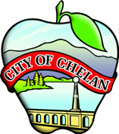

COMMUNITY DEVELOPMENT DIRECTOR Recruitment

Candidate Supplemental Questions

In order for the City to get a better sense of your writing skills and additional insights into your experience, please answer the following questions. Kindly limit your answers to one page and once completed please upload your answers as part of your online application.

1) Given what you know about the city organization, how would you help make the organization better?

2) As a Community Director, you'll be confronted with the task of handling growth challenges while balancing a prospering tourism economy, which can often make living in the community less affordable for residents. How would you plan to address this problem while still acknowledging the role of tourism? Could you suggest a plan or initiative that would help balance economic growth with the preservation of the community's unique character?

