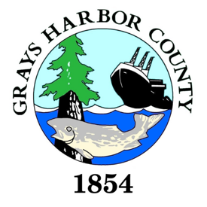
COUNTY ADMINISTRATOR Recruitment

Candidate Supplemental Questions

In order for the County to get a better sense of your writing skills and additional insights into your experience, please answer the following questions. Kindly limit your answers to one page and once completed please upload your answers as part of your online application.

1) What have you learned about Grays Harbor County and the area that interests you and why is now a good time in your career to consider this position?

2) The County Administrator will need to quickly build trust with the Board of Commissioners and department directors to enhance communication and consensus. Please describe your experience in this area. What strategies have you implemented in the past, or would implement in this role, to be successful in this area?

3) Please give a brief overview of your management style.

