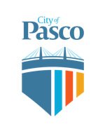
DEPUTY CED DIRECTOR Recruitment

Candidate Supplemental Questions

In order for the City of Pasco to get a better sense of your writing skills and additional insights into your experience, please answer the following questions. Kindly limit your answers to one page and once completed please upload your answers as part of your online application.

1) Why is this a good time for you to pursue this position in your career? What about the City of Pasco that interests you?

2) How does your current job relate to this position? Have you led system changes in your current job?

