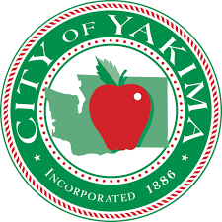

Director of Community and Economic Development Recruitment

Candidate Supplemental Questions

In order for the City to get a better sense of your writing skills and additional insights into your experience, please answer the following questions. Kindly limit your answers to one page and once completed please upload your answers as part of your online application.

1) Please tell us why you are interested in this position and why it is a good time in your career to come to the City of Yakima?

2) Please give a brief description of your most successful update of a city’s comprehensive plan. Why was it successful?

