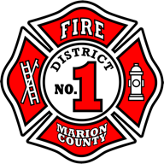

DEPUTY FIRE CHIEF RECRUITMENT
Candidate Supplemental Questions

To give MCFD1 a better sense of your communication skills and experience, please answer the following questions. Kindly limit your answers to one page.

1) Operational Leadership & Accountability
Describe a time when you were responsible for day-to-day operations in the absence of a Fire Chief or with limited executive support. How did you set expectations, hold personnel accountable, and ensure operational continuity while maintaining trust with labor and line staff?

2) Leading Through Change & Culture
MCFD1 is experiencing organizational and regional change, including new leadership, evolving partnerships, and increasing operational complexity. How have you successfully led cultural or organizational change in a fire organization, particularly when resistance or uncertainty existed? What specific actions did you take to gain buy-in and deliver results?

3) Regional Collaboration & Strategic Operations
This role requires close coordination with neighboring agencies, joint operations, and system standardization. Provide an example of how you have worked with external partners to improve interoperability, efficiency, or service delivery. What was your role, and what measurable outcomes resulted from that collaboration?

