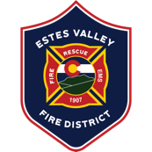

FIRE CHIEF RECRUITMENT
Candidate Supplemental Questions

To give Estes Valley Fire Protection District a better sense of your communication skills and experience, please answer the following questions (and provide your name). Kindly limit your answers to one paragraph per question and no more than two pages total.

NAME:

1) Organizational Leadership & Culture
Describe a time when you led an organization or division through cultural change. How did you address resistance, build trust, and create alignment across different groups while maintaining accountability?

2) Strategic & Financial Leadership
Provide an example of how you have developed and implemented a long-term strategic, financial, or capital plan. How did you communicate needs to stakeholders, and what was the outcome?

3) Wildfire & Community Risk Leadership
Estes Valley Fire Protection District operates in a high-risk wildfire environment with strong community expectations. Describe your experience leading wildfire mitigation, preparedness, or response efforts, and how you have partnered with community stakeholders to improve outcomes.

